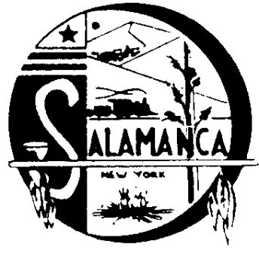
Salamanca Area Development Corp

225 Wildwood Avenue, Suite 9, Salamanca, NY 14779
Phone (716) 945-3230, Fax (716) 945-5033

Annual Real Property Report

2022-2023

The Salamanca Area Development Corp. owns 50 Morningside Ave. in the City of Salamanca.73.073-6-2.3 is a Warehouse building on a 1.10 acre lot off of the Seneca Nation Indian Reservation.

Currently the building is rented to East End Plastics as Ware house storage for $2,200 per month.

The Salamanca Area Development Corp. owns 649 East State St. in the City of Salamanca. 73.073-6-8 is a commercial building on a 1.25 acre lot on the Seneca Nation Indian Reservation.

Currently the building is rented to Costello Manufacturing as a commercial build for their business and pay $1,187.50 monthly.

