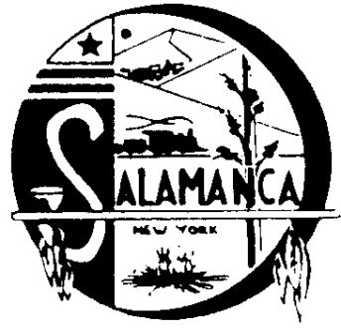
Salamanca Industrial Development Agency

225 Wildwood Avenue, Suite 9, Salamanca, NY 14779
Phone (716) 945-3230, Fax (716) 945-5033

SUMMARY OF MEETING MINUTES
FOR IDA and SADC BOARD

Feb. 2nd, 2022
4:00 P.M.

CALL TO ORDER the IDA and SADC

Board Member John Hill called a combined meeting to order at 4:16 P.M. for the Salamanca IDA and The Salamanca Area Development Corp.

Board Members: Michael Zaprowski, John Hill, David Skiba
Board Members absent: Brooke Baker and Thomas Cole
Attorney: Robert McLaughlin (absent), Jake Capecelatro (via phone)
Employees: Shayla Adamic, Gary Milliman
Guest: NONE
Press: NONE

APPROVAL OF MINUTES

John Hill made a motion to approve the Salamanca IDA’s and SADC’s January 5th, 2022 minutes, David Skiba seconded the motion.

Ayes: Michael Zaprowski, David Skiba, & John Hill
Nays: None. Motion Carried

JOURNAL ENTRY’S

Michael Zaprowski made a motion to approve the Salamanca IDA’s and SADC’s Journal Entry’s. David Skiba seconded the motion.

Ayes: Michael Zaprowski, David Skiba, & John Hill
Nays: None. Motion Carried

APPROVAL OF REPORT, TRANSFERS, AND PAY BILLS

Michael Zaprowski made a motion to approve the Salamanca IDA’s and SADC’s reports, transfers, and bills. David Skiba seconded the motion.

Ayes: Michael Zaprowski, David Skiba, & John Hill
Nays: None. Motion Carried

NEW BUSINESS

- Gary Milliman provided the board with an update regarding the Salamanca School district’s interest in the IDA’s Rochester Street property. Environmental testing has been done the tester stated that further testing would be required due to the history of the property. The further testing costs more than the previous testing and at this time the board is concerned with where our manufacturers would go due to the School wishing to purchase the whole property and not just the vacant portion of it.

- Gary Milliman discussed that the majority of repairs have been made at the recently purchased Fire Hall, a for rent sign has been put on the door of the vacant office space and Gary Milliman has been in contact with the Salamanca Press to get the rental space published in the newspaper.

EXECUTIVE SESSION

A motion was made by John Hill and seconded by David Skiba to go into executive session at 4:38 P.M. to discuss Section 8 fraud finding. Motion passed.

A motion was made at 4:45 P.M. by Mike Zaprowski and seconded by John Hill to come out of executive session. Motion was passed.

OLD BUSINESS

- None.

SADC

- None.

SECTION 8 PROGRAM

- None.

ADJOURNMENT

Mike Zaprowski made a motion to adjourn at 5:05 P.M. John Hill seconded the motion.

Ayes: John Hill, Michael Zaprowski, & David Skiba
Nays: None. Motion Carried

Respectfully submitted,
Shayla Adamic & Gary Milliman

