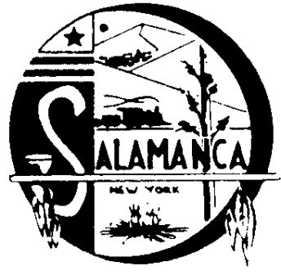
Salamanca Industrial Development Agency

225 Wildwood Avenue, Suite 9, Salamanca, NY 14779
Phone (716) 945-3230, Fax (716) 945-5033

SUMMARY OF MEETING MINUTES
FOR IDA and SADC BOARD

March 2nd, 2022
4:00 P.M.

CALL TO ORDER the IDA and SADC

Board Member John Hill called a combined meeting to order at 4:04 P.M. for the Salamanca IDA and The Salamanca Area Development Corp.

Board Members: Michael Zaprowski, John Hill, David Skiba, Brooke Baker & Thomas Cole
Board Members absent: None
Attorney: Robert McLaughlin (via phone)
Employees: Laurie Andrews
Guest: NONE
Press: NONE

APPROVAL OF MINUTES

Tom Cole made a motion to approve the Salamanca IDA’s and SADC’s February 2nd, 2022 minutes, John Hill seconded the motion.

Ayes: Michael Zaprowski, David Skiba, John Hill, Thomas Cole, & Brooke Baker
Nays: None. Motion Carried

JOURNAL ENTRY’S

John Hill made a motion to approve the Salamanca IDA’s and SADC’s Journal Entry’s. Brooke Baker seconded the motion.

Ayes: Michael Zaprowski, David Skiba, John Hill, Thomas Cole, & Brooke Baker
Nays: None. Motion Carried

APPROVAL OF REPORT, TRANSFERS, AND PAY BILLS

John Hill made a motion to approve the Salamanca IDA’s and SADC’s reports, transfers, and bills. Mike Zaprowski seconded the motion.

Ayes: Michael Zaprowski, David Skiba, John Hill, Thomas Cole & Brooke Baker
Nays: None. Motion Carried
NEW BUSINESS

- Laurie Andrews presented the board with a quote we received from Overhead Doors for the repairs of the overhead garage door at the Monroe Table building on Rochester St.. Gary will call them to accept the bid and have the work completed.

- Laurie Andrews updated the board on the Fire Hall building and the necessary emergency repairs due to gas leaks.

-Laurie Andrews reported a cracked pipe was found at the doctor’s office at 117 Main Street and Crosby’s would need to repair this.

-Laurie Andrews reported to the board that Gary Milliman has completed Paris ABO training and Laurie Andrews was schedule to complete it on March 4, 2022.

OLD BUSINESS

- Laurie Andrews reported on the school’s interest in the Rochester Street lot and the costs associated with phase 2 of environmental testing.

- Laurie Andrews reported the plan for lobbying the City Council for Casino funds as been put on hold for now as the Seneca Nation is again withholding funds. This can be re-visited at a later time after the issue between the Nation & the State has been resolved.

-The discussion on 231-235 Main Street property was put on hold per the request of John Hill.

Laurie Andrews & Robert McLaughlin discussed the Great Wall real estate loan closing status with the board.

SADC

- Robert McLaughlin informed the board he was working on the SADC compliance issue and will send the board a memo on his findings and we should be able to discuss at the next board meeting.

SECTION 8 PROGRAM

- Robert McLaughlin requested Shayla Adamic send information to him on the new fraud case.

ADJOURNMENT

Mike Zaprowski made a motion to adjourn at 4:43 P.M. Brooke Baker seconded the motion.

Ayes: John Hill, Michael Zaprowski, David Skiba, Thomas Cole, & Brooke Baker
Nays: None. Motion Carried

Respectfully submitted,
Laurie Andrews

