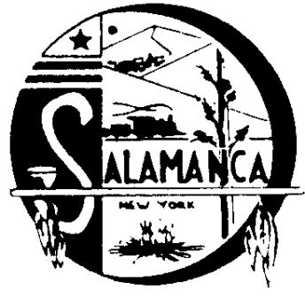
Salamanca Industrial Development Agency

225 Wildwood Avenue, Suite 9, Salamanca, NY 14779
Phone (716) 945-3230, Fax (716) 945-5033

Fiscal Year 2021 to 2022 Measurement report

- The Salamanca Industrial Development Agency continues to rent it’s industrial buildings to industries to continue to supply employment opportunities to area residence:

  - Monroe Table, 270 Rochester Street $1,287.00 Monthly $15,4444.00 Annually
  - Snyder Manufactures, 252 Rochester Street $ 4,091.00 Monthly $49,092.00 Annually
  - Norton Smith Hardwoods, 25 Morningside Ave. $ 3,841.00 Monthly $46,092.00 Annually
  - UPMC, 117 Main Street $ 2,478.85 Monthly $29,746.20 Annually
  - Catt. Co. 117 ½ Main Street $ 2,793.00 Monthly $33,516.00 Annually

- The Salamanca Housing Choice Voucher Program is a division of the Salamanca IDA. Also called the Section 8 program, it houses approximately 140 families with assistance in paying for their rent. The Section 8 program insures that the units are decent, safe and sanitary for the low income population to live in the City of Salamanca.

