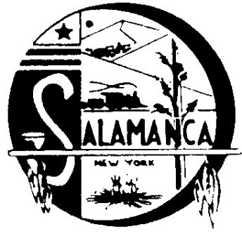
Salamanca Area Development Corp

225 Wildwood Avenue, Suite 9, Salamanca, NY 14779
Phone (716) 945-3230, Fax (716) 945-5033

2021-2022

The Salamanca Area Development Corp Measurement Report:

The SADC owns an Industrial Building at 50 Morningside in Salamanca, New York. Currently East End Plastics is renting the building as a ware house. They pay a monthly rent of $2,200, $26,400 annually.

The SADC owns a commercial building at 649 East State St. in Salamanca, New York.

Currently Costello Manufacturing is renting the building for their business. They pay a monthly rent of $1,187.50, $14,250.00 annually

The loan with Monroe Table is current with a balance of $42,231.96.

