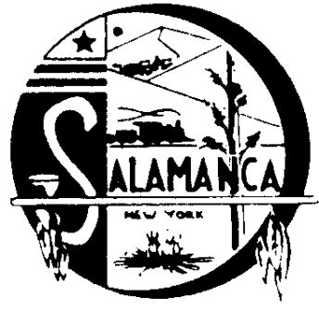
Salamanca Area Development Corp

225 Wildwood Avenue, Suite 9, Salamanca, NY 14779
Phone (716) 945-3230, Fax (716) 945-5033

2021-2022

The Salamanca Area Development Corp owns:

The SADC gave a loan in the amount of $58,000 to Monroe Table Inc. to purchase Equipment from RT Machine Company, Inc. Monroe Table Company is a certified by the Veteran Service Administration as a Service Disabled Veteran Owned Small Business. https://www.monroetable.com/ Currently Monroe Table employees approximately 20 employees, working 2 shifts.

Warehouse/Industrial Buildings

50 Morningside Dr Warehouse It was transferred ownership from the IDA 9/2016

The Warehouse is lease with East End Plastics for $2,200.00 per month.

Commercial/manufacturing building

649 East State St, Commercial/manufacturing, It was bought for $140,000.00 11/2021

The building is leased with Costello manufacturing for $1,187.50 per month.

In 2018 a Flag Pride Account was opened. Donations from area residents purchased American Flags and Seneca Nation Flags that are currently flying on Wildwood Bridge, Main Street Bridge, The whole length of Main Street and Broad Street. More than 100 flags are flying thanks to the community’s support.

A plaque recognizing those who donated to Flag Pride is hanging in Salamanca City Hall.

2020 A hometown program was started within the City of Salamanca. The Salamanca American Legion received a grant of $4,000 to assist with the purchase of the Banner’s. As of March 2021, over 300 banners have been hung through out the City of Salamanca. Starting September 2020, the Salamanca American legion has taken the program over.

